1. 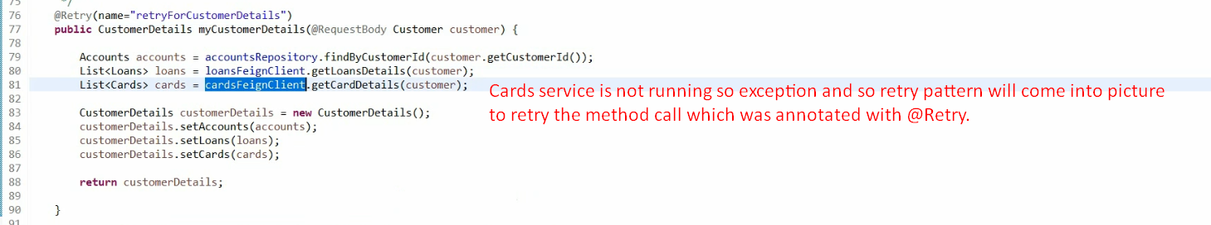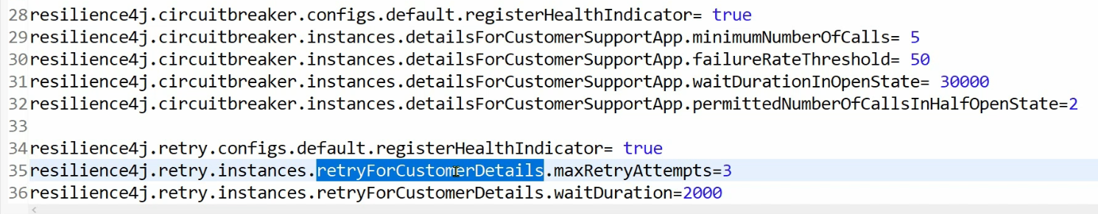
2. 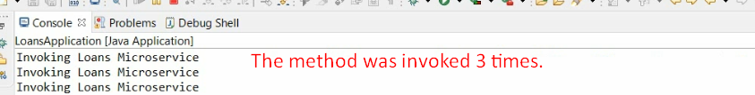
3. 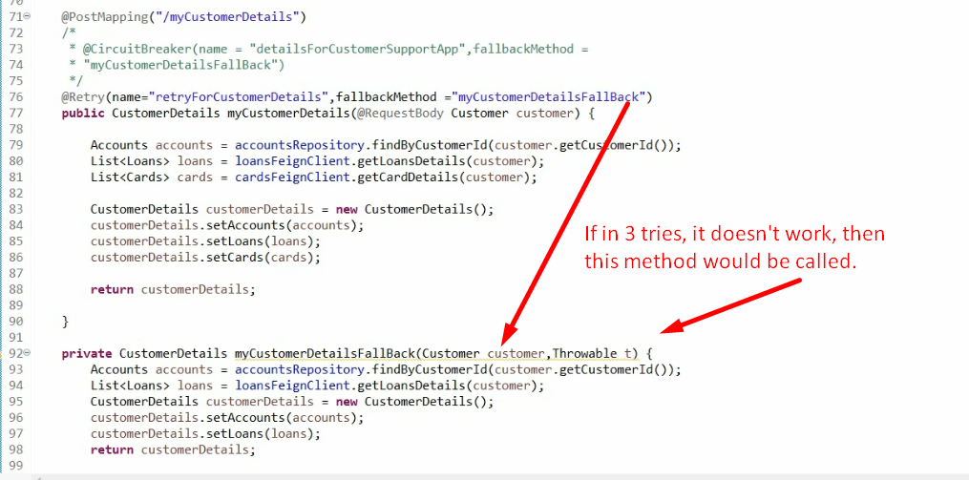
4. **NOTE**: Be careful, retry pattern can make your app slow.